This reference guide outlines basic definitions and SQL commands using SQL Server dialect.

SAMPLE DATA
The data used in examples throughout this guide are taken from the Chinook database and limited to the following tables and columns.

Table 1: Invoice Table
COLUMN 1 | COLUMN 2 | COLUMN 3 | COLUMN 4 | COLUMN 5
InvoiceId | CustomerId | InvoiceDate | BillingState | Total

Table 2: Customer Table
COLUMN 1 | COLUMN 2 | COLUMN 3 | COLUMN 4 | COLUMN 5 | COLUMN 6
CustomerID | FirstName | LastName | City | State | Country

QUERYING TABLES
Get all the columns from a table.
SELECT *
FROM Custome r;

Get one column from a table.
SELECT Country
FROM Custome r;

Get two or more columns from a table.
SELECT FirstName, LastName
FROM Custome r;

Get two columns from a table displayed in ascending order.
SELECT FirstName, LastName
FROM Customer
ORDER BY LastName ASC ;

Get two columns from a table displayed in descending order.
SELECT FirstName, LastName
FROM Customer
ORDER BY State DESC ;

Get a unique list from a table.
SELECT DISTINCT State
FROM Custome r;

Get the first 5 rows from a table
SELECT TOP 5 FirstName, LastName
FROM Customer ;

Get an offset number of rows from a table.
SELECT CustomerId, LastName
FROM Customer
ORDER BY CustomerId
OFFSET 10 ROWS FETCH NEXT 5 ROWS ONLY ;

FILTERING DATA
- =: Equal to
- != or <>: Not equal to
- <: Less than
- <=: Less than or equal to
- >: Greater than
- >=: Greater than or equal to
- AND: All conditions must be true.
- OR: At least one condition must be true.
- NOT: The condition must be false.
- BETWEEN: Finds data within a range
- LIKE %: Any number of characters
- LIKE _: A single character

Filtering on Numeric Columns
Get information where criteria is more than or equal to other records.
SELECT CustomerId, Total
FROM Invoice
WHERE Total >= 0.99
Get all information that meets two criteria exclusively.
SELECT CustomerId, Total
FROM Invoice
WHERE Total BETWEEN .50 AND 9.99;

Filtering on Text Columns
Get all information that meets one criteria.
SELECT *
FROM Customer
WHERE Country = ‘Germany’ ;
Get all information that meets two criteria inclusively.
SELECT *
FROM Customer
WHERE Country = ‘Germany’ OR Country = ‘France’ ;
Get all information excluding one criteria.
SELECT *
FROM Customer
WHERE NOT Country = ‘USA’ ;
Get information where criteria starts with something.
SELECT FirstName, LastName
FROM Customer
WHERE LastName LIKE ‘A%’ ;
Get information where criteria skips one (or more) characters.
SELECT FirstName, LastName
FROM Customer
WHERE LastName LIKE ‘_e%’ ;
Get information where criteria does not end with something.
SELECT FirstName, LastName
FROM Customer
WHERE LastName NOT LIKE ‘%A’ ;

Filtering on Multiple Columns
Get all information that meets criteria from two columns.
SELECT CustomerId, Total
FROM Invoice
WHERE Total > 10 AND BillingCity = ‘Paris’;

Filtering on Missing Data
Get all information that meets criteria from two columns.
SELECT CustomerId
FROM Invoice
WHERE Total IS NOT NULL ;

TRANSFORMING DATA
- UPPER/LOWER: Converts text case
- CONCAT: Joins text together
- SUBSTRING: Extracts parts of text
- ROUND: Rounds to a specified number of decimal places
- SUM: Adds values for total calculation
- AVG: Calculates mean average of data
- COUNT: Adds the number of rows
- MIN/MAX: Identifies smallest/largest number.
- FORMAT: Displays components as specified
- GETDATE: Retrieves current date/time

String Data
Convert text data to upper case letters.
SELECT UPPER(FirstName)
FROM Customer ;
Join text to create composite information.
SELECT CONCAT(FirstName, ‘ ‘ , LastName)
FROM Customer ;
Extract parts of a text string (e.g. 1st through 4th characters).
SELECT SUBSTRING(LastName, 1, 4)
FROM Customer ;

Mathematical Functions
Round to the nearest two decimal places.
SELECT ROUND(Total, 2)
FROM Invoice ;
Add values in a set of numbers.
SELECT SUM(Total)
FROM Invoice
WHERE CustomerId = 5 ;
Calculate the mean average of a set of numbers.
SELECT AVG(Total)
FROM Invoice ;

Date and Time Functions
Display date in mm-dd-yyyy format.
SELECT FORMAT(InvoiceDate, ‘MM-dd-yyyy’)
FROM Invoice ;
Get the current date displayed in mm-dd-yyyy format.
SELECT FORMAT (GETDATE(), ‘MM-dd-yyyy’) ;
Calculate the difference between two dates.
SELECT DATEDIFF(day, ‘01-01-2022’, ‘01-01-2023’) ;

Aggregation Functions
Add up the number of records returned.
SELECT COUNT(InvoiceId)
FROM Invoice
WHERE Total > 10
Identify the smallest value in a dataset.
SELECT MIN(Total)
FROM Invoice ;
Identify the largest value in a dataset.
SELECT MAX(Total)
FROM Invoice ;

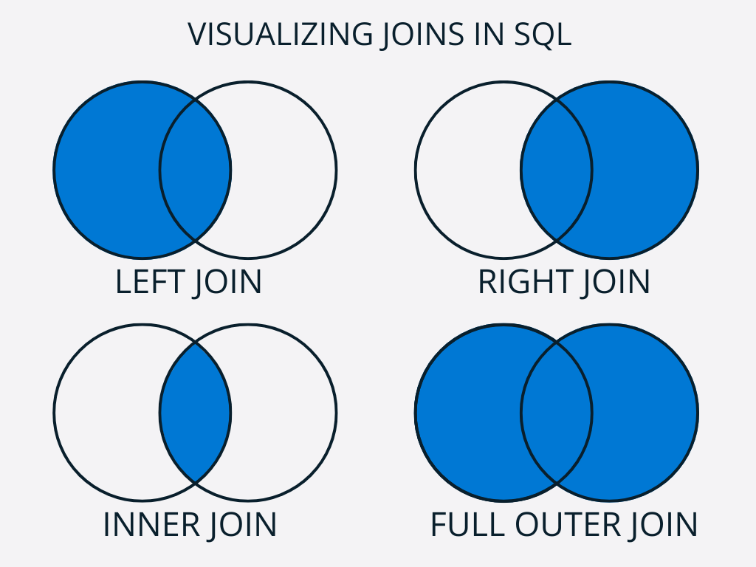
JOINING TABLES
INNER JOIN: Return rows with a match in both tables
(no null values)
SELECT
Customer.CustomerId,
Customer.LastName,
Invoice.InvoiceId
FROM Customer
JOIN Invoice ON Customer.State = Invoice.BillingState ;
LEFT/RIGHT JOIN: Return all rows in the left or right table, and only matching rows in the other table
(null values may be present from the table with all rows)
SELECT
Customer.CustomerId,
Customer.LastName,
Invoice.InvoiceId
FROM Customer
LEFT JOIN Invoice ON Customer.State = Invoice.BillingState ;
FULL OUTER JOIN: Return all rows in both tables
(null values may be present from either table)
SELECT
Customer.CustomerId,
Customer.LastName,
Invoice.InvoiceId
FROM Customer
FULL OUTER JOIN Invoice ON Customer.State = Invoice.BillingState ;

USING ALIASES
COLUMN NAMES: Clarify a new column in the results which is created by concatenating two separate columns.
SELECT CONCAT(FirstName, ‘ ‘ , LastName) AS FullName
FROM Customer ;

TABLE NAMES: Simplify the readability of a complex query by assigning aliases to tables.
SELECT c.CustomerId, c.FirstName, c.LastName, i.Total AS InvoiceTotal
FROM Customer c
JOIN Invoice i ON c.CustomerId = i.CustomerId ;

